## Steps to setup Jupyter Notebook

1. Open Putty and connect to coe-hpc

ssh SJSU_ID@coe-hpc1.sjsu.edu

(get a CPU node, use this command)srun -n 1 -N 1 -c 1 --pty /bin/bash

(get a GPU node, use this command) srun -p gpu --gres=gpu --pty /bin/bash

Your Putty screen will like this below and just minimize it

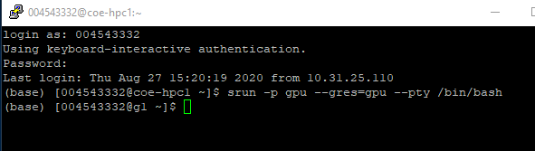

1. Open a Second Putty and first put in the connection information and save it.

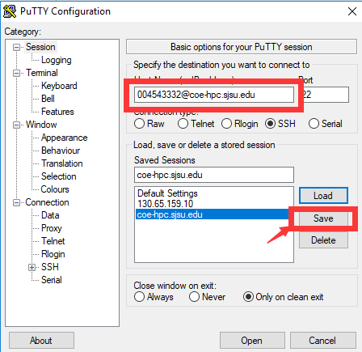

1. Click SSH and Choose Tunnel at bottom, put in a source port, and use the same port number for destination. You can choose anything from 10000-60000, and if there is any conflict with another student, just try another one. Then click open

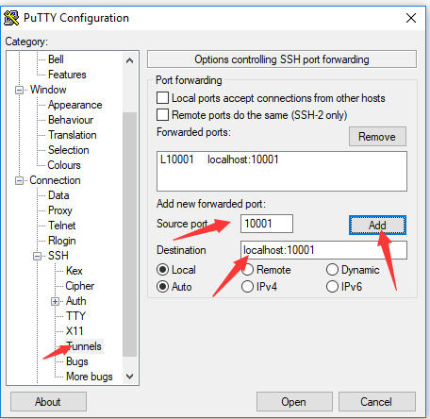

1. Log in to the HPC with your password and type the following command in sequence

(base) [004543332@coe-hpc1 ~]$ ssh -L 10001:localhost:10001 004543332@g1

(base) [004543332@g1 ~]$ module load python3/3.7.0

(base) [004543332@g1 ~]$ jupyter notebook --no-browser --port=10001

Please note that G1 is from step 1 when you ask HPC for a node to use.

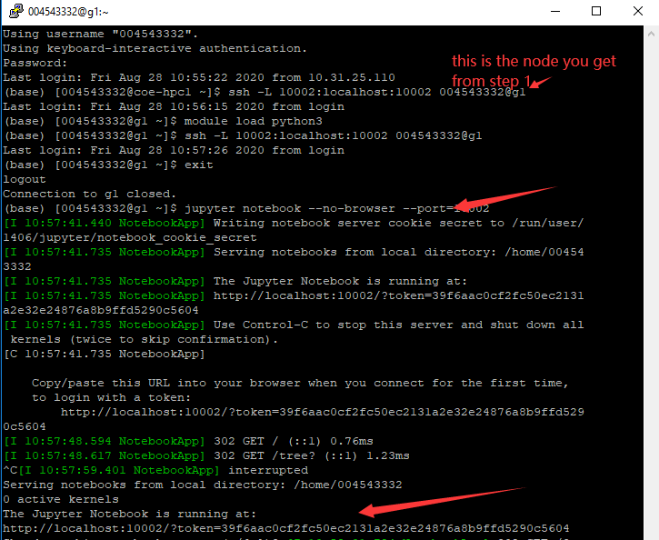

1. Paste the Notebook link from the previous step in your browser, then press ENTER. Enjoy!

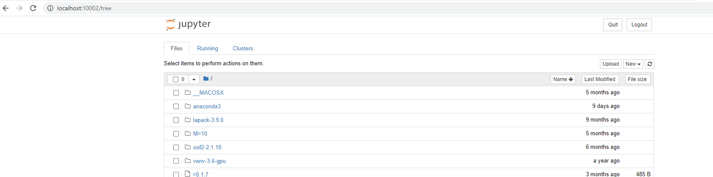

6. At the end of your session, remember to close down Jupyter Notebook (save your notebook, then, in the interactive node terminal window, click CTRL+C, then type y and ENTER), then close down both SSH sessions to the HPC (in the terminal window, type exit, then press ENTER).